May 5, 1916
The Rights of Orphans and Women — Specifically in Relation to Safeguarding the Wealth of Orphans and the Wisdom Behind the Practice of Polygamy
I bear witness that none deserves to be served besides Allah and I bear witness that Muhammad is the servant and messenger of Allah. —
After this, I seek the protection of Allah from the accursed devil.
In the name of Allah, the Beneficent, the Merciful.
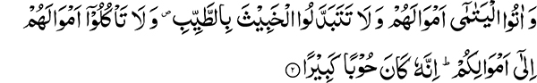
“And give to the orphans their property, and substitute not worthless (things) for (their) good (ones), and devour not their property (adding) to your own property. This is surely a great sin.” (4:2)
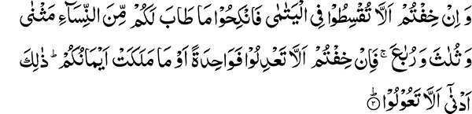
“And if you fear that you cannot do justice to orphans, marry such women as seem good to you, two, or three, or four; but if you fear that you will not do justice, then (marry) only one or that which your right hands possess. This is more proper that you may not do injustice.” (4:3)
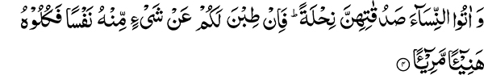
“And give women their dowries as a free gift. But if they of themselves be pleased to give you a portion thereof, consume it with enjoyment and pleasure.” (4:4)
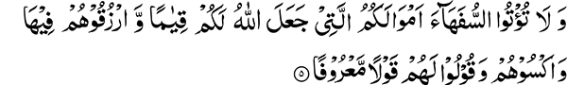
“And make not over your property, which Allah has made a (means of) support for you, to the weak of understanding, and maintain them out of it, and clothe them and give them a good education.” (4:5)
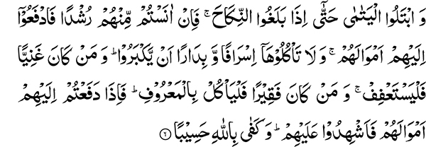
“And test the orphans until they reach the age of marriage. Then if you find in them maturity of intellect, make over to them their property, and consume it not extravagantly and hastily against their growing up. And whoever is rich, let him abstain, and whoever is poor let him consume reasonably. And when you make over to them their property, call witnesses in their presence. And Allah is enough as a Reckoner.” (4:6)
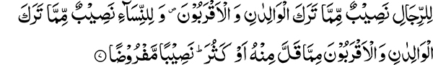
“For men is a share of what the parents and the near relatives leave, and for women a share of what the parents and the near relatives leave, whether it be little or much — an appointed share.” (4:7)
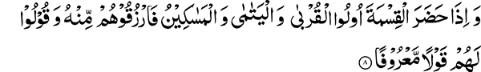
“And when relatives and the orphans and the needy are present at the division, give them out of it and speak to them kind words.” (4:8)
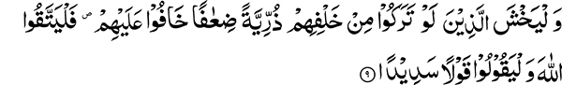
“And let those fear who, should they leave behind them weakly offspring, would fear on their account; so let them observe their duty to Allah and let them speak right words.” (4:9)
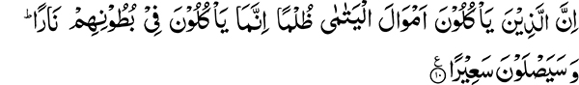
“Those who swallow the property of the orphans unjustly, they swallow only fire into their bellies. And they will burn in blazing fire.” (4:10)
Sympathy with Orphans and the Needy is the Basis of Islam
The very foundation of Islamic teachings, as far as human rights are concerned, is based upon compassion toward orphans and the needy. Even before the call of prophethood, the Holy Prophet was very benevolent toward orphans and those in need. Whatever he had in his possession was spent on them. This is supported by testimony given by Hazrat Khadija at the time when the Holy Prophet received the divine call. These are the words with which she comforted the Holy Prophet. “Nay, by Allah, Allah will never bring thee to grief; surely you do good to your relatives (li tasil-r-rehm), and bear the burden of the weak, and earn for others that which they have not got, and are hospitable to guests and give help when there is real distress” (Bu. 1:1). She mentioned some other things but these four show us the character of the Holy Prophet. The Arabic phrase, “li tasil-r-rehm,” refers to protecting the rights of those who are blood relations. This includes those who are directly related and those with whom a relationship is established through mothers and wives. These were the ties of relationship safeguarded by the Holy Prophet. “And you earn for him who is unable to earn for himself, bear the burden of one who is unable to bear his own, and help others who are in distress.” Such were the noble traits of the Holy Prophet’s character witnessed to by Hazrat Khadija, his wife and closest companion.
Perfect Example of Mercy and Compassion
Hazrat Khadija spent fifteen years of married life with the Holy Prophet before he received the Divine call. The Holy Prophet was not wealthy. Through his marriage with Hazrat Khadija, who was quite rich, he acquired some wealth. Where did he spend all this wealth? He certainly did not spend it on his personal comfort; rather he used it to help orphans, the needy, slaves, and all those whom he came across who were facing difficulties. His profound passion for caring and compassion for those in need was a hallmark of his character from his earliest years. The result of this overwhelming compassion was the revelation of these verses that heavily stressed the rights of orphans and the needy.
The Greater Goal of a Muslim
Study the earlier revelations of the Holy Quran. What is the great goal for a Muslim to strive for mentioned in these chapters? It is the helping of orphans and the needy described in these words:
“And pointed out to him the two conspicuous ways? But he attempts not the uphill road; And what will make thee comprehend what the uphill road is? (It is) to free a slave, Or to feed in a day of hunger. An orphan nearly related.” (90:10-15)
We also find, “Nay, but you honor not the orphan, nor do you urge one another to feed the poor.” (89:17-18)
These words of the Holy Quran describe the attitude of disbelievers toward orphans and the poor. Practicing Islam is treating orphans with respect and exhorting one another to feed the poor.
The Condition of Orphans in this Age
Muslims, instead of treating their orphans with dignity, have either abandoned their care, leaving it in the hands of Christians, or have left them wandering around in a forsaken and distressed state. Honoring the needs of orphans was amongst the earliest messages of Islam, but regrettably Muslims today have abandoned their duty toward them. In another verse, the Holy Quran states, “Hast thou seen him who belies religion? That is the one who is rough to the orphan and urges not the feeding of the needy” (107:1-3). He who rejects the orphan and does not urge the feeding of the poor is said to be belying religion or disbelieving in the Day of Judgment. By his behavior, he questions being held accountable for his actions.
The Reason for Urging Care of Orphans
Why has so much stress been laid upon empathy toward orphans? It is because the real progress of a nation cannot be gauged by the progress made by a few individuals, while others remain in poverty. Advancement of all members in society and not a few individuals truly reflects the development of a nation. Until all parts of the body are nurtured, it cannot be in a healthy state. In fact, the part of the body that exhibits uninhibited growth in comparison with the rest becomes cancerous and may need to be surgically excised. Thus, when all members of a nation are not given the opportunity to make progress, the nation fails to acquire a position of respect. Wealth concentrated in the hands of a few individuals can be harmful. This is the reason why Islam has, starting with the earliest revelations, stressed the importance of taking care of orphans.
Guarding the Property of Orphans
These verses of chapter Al-Nisa, which I have recited, also stress the rights of orphans. It is stated: “And give to the orphans their property, and substitute not worthless (things) for (their) good (ones).” This enjoins that you have to take care not only of those orphans who are dependent upon you, but you also have to look after those who may own property. In this section specifically, those orphans who have property are mentioned. You are enjoined not to consume their property but to return it to them and not substitute their good things for worthless ones. “And devour not their property (adding) to your own property. This is surely a great sin.” The injunction does not prohibit partnership but what is prohibited is partnership with the intent to consume their property.
Polygamy and Muslims
“And if you fear that you cannot do justice to orphans, marry such women as seem good to you, two, or three, or four; but if you fear that you will not do justice, then (marry) only one or that which your right hands possess. This is more proper that you may not do injustice.” (4:3)
Muslims have spent a lot of effort on this verse of the Holy Quran. If you observe the attitude of Muslim kings, they had several hundred women in their harems. As a result of this excess, those who were in a leadership position wasted their energies, which could have been spent in service of religion and humanity. The whole nation suffered the adverse consequences of this behavior. On the other hand, before the advent of Islam there was no limit amongst Arabs to the number of wives an individual could have.
Why was Polygamy Allowed?
Islam has allowed polygamy, with specific terms, and only under certain conditions. This permission was given in consideration of circumstances that can be quite detrimental for the welfare of a nation, if relief is not provided by allowing limited polygamy. During the battle of Uhud, seventy out of a total of seven hundred Muslims were martyred and the proportion of women increased greatly in the society. If polygamy were not allowed, care of the widows would have been neglected. An orphan is not only a child whose father has passed away. The Arabic word Yatim means one who is left alone; and therefore the term can also be applied to a woman whose husband has passed away.
The Holy Quran tells us that if you cannot do justice to these women, you should marry them. The real occasion for polygamy therefore arose as a consequence of battles after which the number of widows in the society increased. Under these circumstances the moral condition of the society could not have been maintained without permitting polygamy. Nevertheless, this does not mean that polygamy cannot be practiced in any other situation. An individual can be faced with certain other conditions in which he is compelled to practice polygamy. This is why permission for polygamy is granted. When Islam permits something under special circumstances, the breadth of such circumstances can be widened with greatest care.
Polygamy Without a Genuine Need is Unlawful
This however, does not mean that permission is granted without the need being there. Those who indulge in such behavior do not follow the Holy Quran. In fact, they follow their own low desires. Some religions have completely prohibited more than one marriage. This is also incorrect. Islam does not include such an oppressive law; but on the other hand, has legalized polygamy under special circumstances. Sometimes under ordinary circumstances, the need arises to contract more than one marriage. Islam has also given permission to have more than one wife under such circumstances. Those who practice polygamy unnecessarily, merely to satisfy their carnal desires, are committing what is unlawful. Observe that Islam has also permitted divorce, although the Holy Prophet has said, “Out of that which is lawful, divorce is the most displeasing to Allah.” This does not mean that divorce is not allowed under any circumstances. This is like a medicine only to be used when it is necessary. Similarly, according to the Islamic Shariah, more than one marriage is not lawful unless it is necessary.
The Reasons for Polygamy have not been Specified
Different needs arise under different circumstances; therefore the reasons for permitting the lawful practice of polygamy have not been enumerated. This is similar to divorce in which the conditions permitted are not specified. It has been left up to the circumstances of time and conditions of a nation or country. Today in Europe, even though they practice the same religion, different nations have established different set of restrictions in the matter of divorce. In the United States each state has separate legislation dealing with divorce. Since Islam was to be an international religion and is meant for all ages, it did not limit the reasons under which divorce can be granted. It has left it discretionary, depending on the condition of humanity.
Similarly, the reasons for polygamy have not been specified or limited, for different conditions can arise in different ages. For example, in major wars, the number of men can be greatly reduced because of participation in combat. In some countries, men are naturally less in numbers than women. Sympathy for the human race is the basis for allowing polygamy under these circumstances. Some of these circumstances, for example not having any children, apply only specifically to certain individuals.
Polygamy is a Permission and not a Command
Nowhere in the Holy Quran is it stated that you are allowed to divorce. Just as divorce is permitted when the need arises, similarly polygamy is permitted under exceptional circumstances and is not a general command. If having more than one wife was an essential need deserving reward, the words of the Holy Quran quoted above should have commenced with four (rubha) instead of two (mathna), for the former would be deserving of greater reward. Four would then be followed by three, two, and one, in that order.
To Make Polygamy Binding Upon all is Contrary to Normal Conditions Existing in the World
Conditions prevailing in the world should be carefully observed. They are not such that women are twice, thrice, or four times the number of men. In fact, the ratio of men to women is about equal. The Holy Quran does not give any command that is contrary to the facts. Polygamy is a remedial measure for exceptional circumstances and is a mere permission, not a command. This is clearly expressed by the words that follow: “But if you fear that you will not do justice, then (marry) only one or that which your right hands possess. This is more proper that you may not do injustice.” (4:3) Islam has given this permission only subject to certain conditions, without which it is unlawful.
The Real Purpose of Polygamy
The real intent in allowing polygamy under exceptional circumstances has been expressed in the words of the Holy Quran: “This is more proper that you may not do injustice (al la ta‘dil—u).” The real purpose is for a man to improve his moral condition. If having more than one wife leads to deterioration of the moral condition, then monogamy is the preferred course. Imam Shafi has taken the Arabic word “ta‘dil—u” to mean increasing the number of children. The verse would then mean that if you do not have the resources and you keep on having more children through multiple marriages, then the purpose of permitting polygamy is defeated.
Payment of Marriage Dowry is Essential
“And give women their dowries as a free gift (nihlah). But if they of themselves be pleased to give you a portion thereof, consume it with enjoyment and pleasure.” (4:4)
It has become customary these days to fix the amount of dowry without the intention of paying it. It is not permissible to promise exorbitant amounts of dowry without paying. Even the verse that allows a large amount of dowry to be given states:
“And if you wish to have (one) wife in the place of another and you have given one of them a heap of gold, take nothing from it. Would you take it by slandering (her) and (doing her) manifest wrong?” (4:20)
This verse clearly indicates that even a heap of gold, when promised, is to be given; and this is a free gift (nihlah) without expecting any return on the part of the husband.
The Moral Lesson in the Giving of Dowry
Life evolves with the establishment of social relationships. Many lessons need to be learned in this respect. The first lesson taught for this purpose is to make a sacrifice, so that one is ready to spend for even higher causes. If spending for the sake of a spouse is advised, why is it not necessary to spend on even higher causes? Islam aims at progressive strengthening of your moral faculties. By mandating sacrifice for your wives in the form of a marriage dowry, the intent of the Holy Quran is to indicate the priority that needs to be given to spending in the way of Allah who is above all the rulers of the world.
Property not to be Entrusted to the Weak of Understanding
“And make not over your property, which Allah has made a (means of) support for you, to the weak of understanding (sofahā), and maintain them out of it (fī hā), and clothe them and give them a good education.” (4:5)
The Arabic word sofahā means those who are weak in understanding — those who cannot properly safeguard their property. The Holy Quran tells us not to assign property to those who do not understand its proper use. Property has been assigned to us by Allah the Most High as a means of sustenance. If you give it to the weak of understanding they will destroy it. Regarding children, or those, who because of physical or mental handicaps, are not capable of maintaining their property, the command is not to turn over property to them. Maintain them out of it, and clothe them and give them a good education. The Arabic word fī hā indicates that they should be maintained out of this property. It may be used for trade etc. And those to whom the property belongs should be maintained out of its earnings in order to keep the capital from going to waste.
Teach Orphans to Safeguard their Property
“And give them a good education.” Giving them a good education enables them to become capable of handling their finances and spending wisely. The real intent is to turn over the property of the orphan to his custody so that he can benefit from it. That is why it is stated, “And test the orphans until they reach the age of marriage.” Imam Abu Hanifa has set the age of marriage, or maturity, at eighteen. In the language of the Arabs, the age of marriage is synonymous with the age of maturity. That is the reason why it is stated that when they reach the age of marriage, “Then if you find in them maturity of intellect, make over to them their property.”
The guardian of an orphan may resort to wasteful spending under the apprehension that his ward will take over the property as soon as they reach maturity. To prevent such wasteful spending it is further added:
“And consume it not extravagantly and hastily against their growing up. And whoever is rich, let him abstain, and whoever is poor let him consume reasonably. And when you make over to them their property, call witnesses in their presence. And Allah is enough as a Reckoner.” (4:6)
Law of Inheritance in Islam is Inclusive of Both Men and Women
“For men is a share of what the parents and the near relatives leave, and for women a share of what the parents and the near relatives leave, whether it be little or much — an appointed share.” (4:7)
The Holy Quran apportions both men and women a share in the inheritance while the Arabs traditionally excluded women from inheriting property. Proverbially, only he who was able to use a spear could inherit property. Islam put an end to this practice. The Holy Quran condemns this custom and states that both men and women are entitled to a fixed portion of the inheritance whether it is a small or a large amount.
“And let those fear who, should they leave behind them weakly offspring, would fear on their account; so let them observe their duty to Allah” (4:9). These words of the Holy Quran tell us to treat orphans and needy mercifully for one could die and similarly leave behind small children who are in a pitiful state.
“And let them speak right words” (4:10). Speaking the right words refers to advising them gently that it was inappropriate to resort to beggary. Those who are in possession of the property of orphans should, however, not let them go empty handed but rather give them sufficient to meet their needs.
Penalty for Illegally Consuming the Property of the Orphan
The admonition against illegal consumption of the orphan’s property is repeated again with the warning: “Those who swallow the property of orphans unjustly, they swallow only fire into their bellies. And they will burn in blazing fire” (4:10)
The Second Sermon
Special Address to the Women, Encouragement to Pay Zakaat
Some women, because of lack of religious knowledge, are unaware of the etiquette of the Friday sermon. One of these requirements is to be quiet while the sermon is being delivered. Sometimes, because of children crying, they are unable to hear. I therefore want to specially remind them that Allah the Most High has frequently made us aware of safeguarding the rights of orphans. The orphan, is that extremely helpless individual, who has no one to look after his interests. There is a special message for us in this. Observe that this chapter (Al-Nisa) begins with the words, “O people, keep your duty to your Lord.” This was followed by the injunction to safeguard the property of the orphan. This means that you are commanded to safeguard the rights of the weakest members of society. It should serve as a reminder of how essential it is to fulfill our rights and obligations toward the Almighty who is the All Seeing, Hearing. This is something that we need to heed.
Safeguard also the Rights of Allah
For this reason, I want to draw the attention of all men and women toward this important matter. The Holy Quran has not appointed any specific month for giving obligatory charity (Zakaat). People generally have fixed the month of Rajab (Islamic calendar) to pay their Zakaat dues. I am therefore drawing your attention to this: that God also has some rights. Allah the Most High has kept the commandment of Zakaat along with the commandments for prayer. This is specifically God’s right, which you consume. God states in the Holy Quran:
“And those who hoard up gold and silver and spend it not in Allah’s way — announce to them a painful chastisement, On the day when it will be heated in the Fire of hell, then their foreheads and their sides and their backs will be branded with it: This is what you hoarded up for yourselves, so taste what you used to hoard” (9:34-35).
Precepts of Zakaat
Zakaat is due from the accumulated wealth of men and women at a rate of two and a half percent. It should be collected in a central treasury. It is inappropriate to spend it according to one’s wishes. There are different categories of spending for Zakaat; therefore, it should be collected in one location before being disbursed into various categories. Muslims are generally very giving for charitable purposes, but if this charity is employed for a permissible expenditure, it can serve a very useful purpose. It is very essential to pay attention to the rights of God. Life is a temporary affair. No one takes away any portion of his wealth with him. Just as we come into this world empty handed, we leave it without any possessions. Wealth keeps on changing hands. Today it may be in the hands of one individual while tomorrow someone else will have it. Those who do not care for the rights of God and have a greater love for wealth, also have to part with it in the end. The love of God cannot enter the heart imbued with the love of wealth. Islam has therefore set some principles for spending in the way of Allah and from amongst them Zakaat has been made compulsory. Those who cannot pay this because they have a greater love in their hearts for wealth than for the love of Allah are acting against Islamic principles.
The Real Purpose for the Coming of Prophets
The purpose of a prophet’s coming is to create love of the true God in the hearts of men while turning them away from the love of wealth and the temporary material comforts of this world. This is why prophets do not like to leave behind any wealth as inheritance. At the time of his death, the Holy Prophet gave away in charity the last dirham (penny) left in his house. Everyone cannot go to this extent; therefore ordinary people have been given some specific facilitations in this matter. I have conveyed the message to you and have relieved myself of my duty in this matter. Those who are willing to listen need to pay attention. I have conveyed to you that you should be fearful of God and fulfill His rights without delay. Every individual after his death will be held accountable for his own deeds. If someone consumes the rights of God and leaves behind thousands of rupees in inheritance, his inheritors will not be held accountable on his behalf. Every man and woman should therefore understand their responsibilities and fulfill them. Try to lead exemplary lives. Become familiar with your responsibilities in this matter and act upon them. Also, explain this to others and serve as a practical example.

